CAMBERLEY TOWN YOUTH F.C.
Match Confirmation Details
Teams |  |  | v
Date
KO Time
Age Group
Home Team Manager and Mobile Number
Format  (Indicate as appropriate) | 5v5 | 7v7 |  | 9v9 |  | 11v11
Match  (Indicate as appropriate) | Friendly | League |  | Cup/Trophy Event
Venue Address  (Including postcode  and map link) | Frimley Green Recreation Ground  Frimley Green road  Frimley Green  Surrey  GU16 6JY
Respect | Please ensure your parents/spectators remain  behind the Respect lines at all times.
Any other issues  (venue, directions,  parking etc) | Kit: Red and white striped jerseys, red shorts and red socks  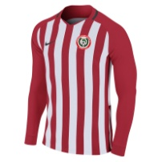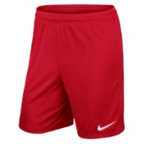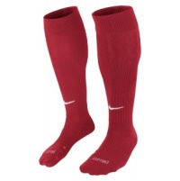
Nearest Hospital | Frimley Park Hospital (with children’s A&E)  Portsmouth Rd, Frimley, Camberley GU16 7UJ
We look forward to welcoming you and your team.
Please kindly confirm receipt of this communication.
www.ctyfc.co.uk
@ctyfc_1973

