CAMBERLEY TOWN YOUTH F.C.
Match Confirmation Details
Teams |  |  | v
Date
KO Time
Age Group
Home Team Manager and Mobile Number
Format  (Indicate as appropriate) | 5v5 | 7v7 |  | 9v9 |  | 11v11
Match  (Indicate as appropriate) | Friendly | League |  | Cup/Trophy Event
Venue Address  (Including postcode  and map link) | The Polo Fields (opposite the Military Stadium)  Queen’s Avenue, Aldershot, GU11 2JL
Respect | Please ensure your parents/spectators remain  behind the Respect lines at all times.
Any other issues  (venue, directions,  parking etc) | Please park in the Polo Fields Car Park as indicated on the map.  Kit: Red and white striped jerseys, red shorts and socks  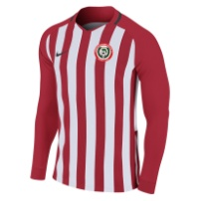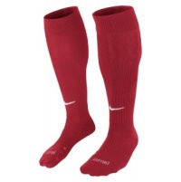
Nearest Hospital  Nearest AED | Frimley Park Hospital (with children’s A&E), Portsmouth Rd GU16 7UJ  Aldershot Garrison Sports Centre, GU11 2LQ
We look forward to welcoming you and your team.
Please kindly confirm receipt of this communication.
www.ctyfc.co.uk
@ctyfc_1973

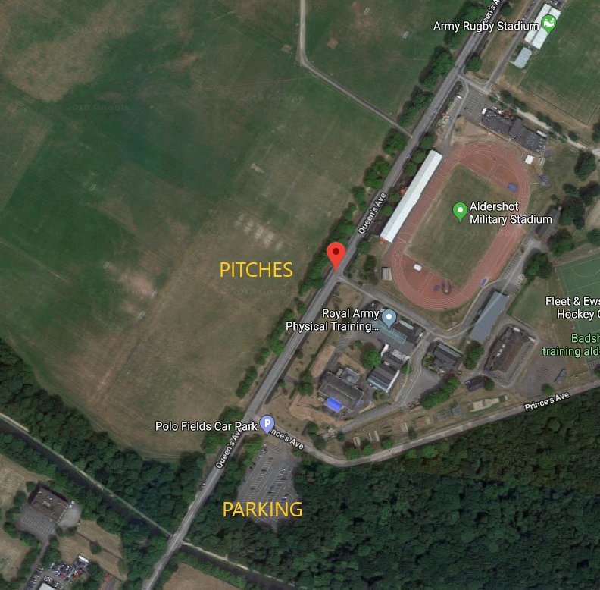
CAMBERLEY TOWN YOUTH F.C.
Queen’s Avenue - MAP
COVID-19 Guidance
Please visit www.ctyfc.co.uk to see our club specific COVID-19 guidance.
Please dispose of all litter considerately and practise good hygiene at all times.

TEST & TRACE
The QR code for the venue that can be used in line with the NHS COVID 19 app is attached here for your convenience. Checking in with this code is voluntary as per recent government guidance.

AS THIS IS ARMY LAND, NO FILMING OR PHOTOGRAPHY IS ALLOWED ON THESE PITCHES.

