CAMBERLEY TOWN YOUTH F.C.
Match Confirmation Details
Teams |  |  | v
Date
KO Time
Pitch
Age Group
Home Team Manager and Mobile Number
Format  (Indicate as appropriate) | 5v5 | 7v7 |  | 9v9 |  | 11v11
Match  (Indicate as appropriate) | Friendly | League |  | Cup/Trophy Event
Venue Address | Redwood Campus, South Camberley Primary School, Frimley Road, Camberley, Surrey, GU15 2QB
Respect | Please ensure your parents/spectators remain  behind the Respect lines at all times.
Information  (venue, directions,  parking etc) | PLEASE AVOID BANGING BOOTS / LEAVING MUD IN THE CAR PARK AND USE THE BOOT SCRAPERS PROVIDED  Please ensure that you park in designated spaces. If the car park is full, please do not remove cones from grass verges but park in surrounding side streets which are a two minute walk to the school campus. Please do not park at The Crabtree Pub.  It is a school campus so we kindly request no smoking and no dogs are allowed on site.  Kit: red shorts, red and white striped jerseys, red socks  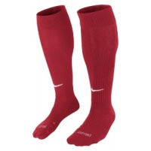
Nearest Hospital | Frimley Park Hospital (with children’s A&E)  Portsmouth Rd, Frimley, Camberley GU16 7UJ
We look forward to welcoming you and your team.
Please kindly confirm receipt of this communication.
www.ctyfc.co.uk
@ctyfc_1973

PITCH LAYOUT
No smoking or dogs on site please
