CAMBERLEY TOWN YOUTH F.C.
Match Confirmation Details
Teams |  |  | v
Date
KO Time
Age Group
Pitch Number
Home Team Manager and Mobile Number
Format  (Indicate as appropriate) | 5v5 | 7v7 |  | 9v9 |  | 11v11
Match  (Indicate as appropriate) | Friendly | League |  | Cup/Trophy Event
Venue Address  (Including postcode  and map link) | Frimley Green Recreation Ground  Frimley Green Road  Frimley Green  Surrey  GU16 6JY
Respect | Please ensure your parents/spectators remain  behind the Respect lines at all times.
Any other issues  (venue, directions,  parking etc) | Kit: Red and white striped jerseys, red shorts and red socks  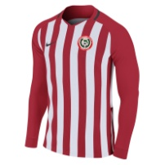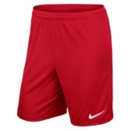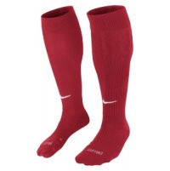
Nearest Hospital  Nearest AED | Frimley Park Hospital (with children’s A&E), Portsmouth Rd, GU16 7UJ  Frimley Green Football Club (if open) or Frimley Green Medical Centre, GU16 6QQ or Frimley Lodge GU16 6HY
We look forward to welcoming you and your team.
Please kindly confirm receipt of this communication.
www.ctyfc.co.uk
@ctyfc_1973

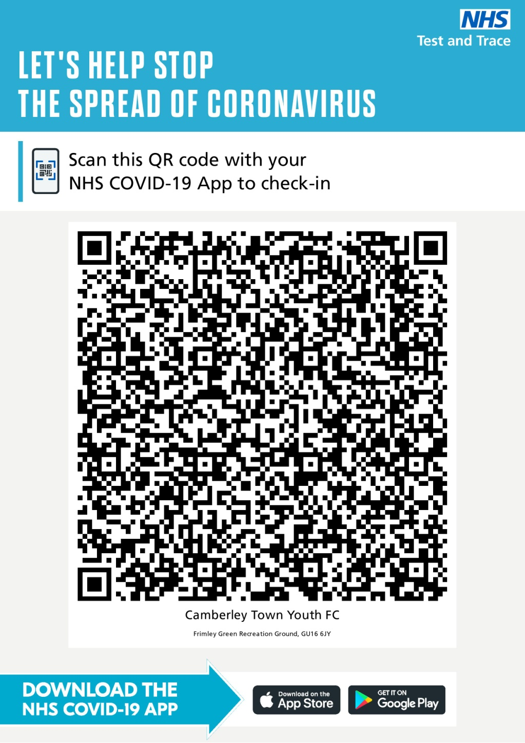
PHOTOGRAPHY & FILMING
Our team do/ do not give permission for photography and filming on match days.
If permission is granted then please use photos for personal use – we ask that nothing is posted to social media.

If your team has any issues with photography or filming then please make these known to the team manager/coach before the game.

COVID-19 Guidance
Please visit www.ctyfc.co.uk to see our club specific COVID-19 guidance.
Please dispose of all litter considerately and practise good hygiene at all times.

TEST & TRACE
The QR code for the venue that can be used in line with the NHS COVID 19 app is attached here for your convenience. Checking in with this code is voluntary as per recent government guidance.

