CAMBERLEY TOWN YOUTH F.C.
Match Confirmation Details
Teams |  |  | v
Date
KO Time
Age Group
Pitch Number
Home Team Manager and Mobile Number
Format  (Indicate as appropriate) | 5v5 | 7v7 |  | 9v9 |  | 11v11
Match  (Indicate as appropriate) | Friendly | League |  | Cup/Trophy Event
Venue Address  (Including postcode  and map link) | Frimley Green Recreation Ground  Frimley Green Road  Frimley Green  Surrey  GU16 6JY
Respect | Please ensure your parents/spectators remain  behind the Respect lines at all times.
Any other issues  (venue, directions,  parking etc) | Kit: Red and white striped jerseys, red shorts and red socks  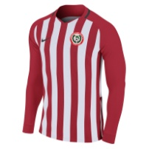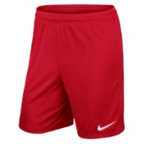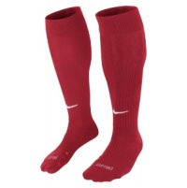
Nearest Hospital | Frimley Park Hospital (with children’s A&E)  Portsmouth Rd, Frimley, Camberley GU16 7UJ
We look forward to welcoming you and your team.
Please kindly confirm receipt of this communication.
www.ctyfc.co.uk
@ctyfc_1973

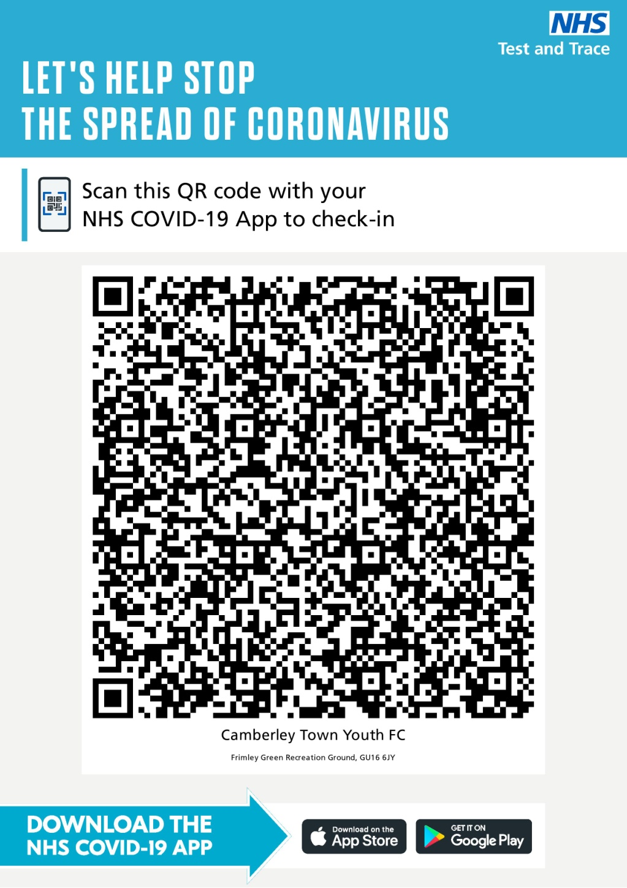
COVID-19 Guidance
Please visit www.ctyfc.co.uk to see our club specific COVID-19 guidance. If you or anyone on your team has COVID-19 symptoms then please look to postpone/cancel this fixture.

Players are asked to respect the new rules of the game and all signage at the venue. Please arrive in full match kit as there are no changing room facilities available. Pleae dispose of all litter considerately.

TRACK & TRACE
We are using the NHS COVID 19 app to assist with their test and trace methods. On the day of the match, please ask all in attendance to scan the following to check into the venue.

